Data Structure and Algorithm

Laboratory Activity No. 1

Object-oriented Programming

|  |  |
| --- | --- |
| *Submitted by:* | *Instructor:* |
| Eulin, Ryan Bertrand B. | Engr. Maria Rizette H. Sayo |

July 26, 2025

# Objectives

This laboratory activity aims to implement the principles and techniques in object-oriented programming specifically through:

* Identifying object-orientation design goals
* Identifying the relevance of design pattern to software development

# Methods

* Software Development
  + The design steps in object-oriented programming
  + Coding style and implementation using Python
  + Testing and Debugging
  + Reinforcement of below exercises
  1. Suppose you are on the design team for a new e-book reader. What are the primary classes and methods that the Python software for your reader will need? You should include an inheritance diagram for this code, but you do not need to write any actual code. Your software architecture should at least include ways for customers to buy new books, view their list of purchased books, and read their purchased books.

<https://drive.google.com/file/d/1bjudMDJ-s5xZF3xRqSxquSNCse_DY3tQ/view?usp=sharing>

* 1. Write a Python class, Polygons that has three instance variables of type str, int, and float, that respectively represent the name of the polygon, its number of sides, and its area. Your class must include a constructor method that initializes each variable to an appropriate value, and your class should include methods for setting the value of each type and retrieving the value of each type.

DSA_lab_1_Report

# Results

Here is my answer in Part A where in we’re task to make a diagram of e-book reader where we need to have a primary classes and methods, this pic shows that first, the customer, library and store go’s to the e-book reader to find what books they need. They all have the ability to see or view the books and if they go to the store and purchased book they also need to do the payment.  
  
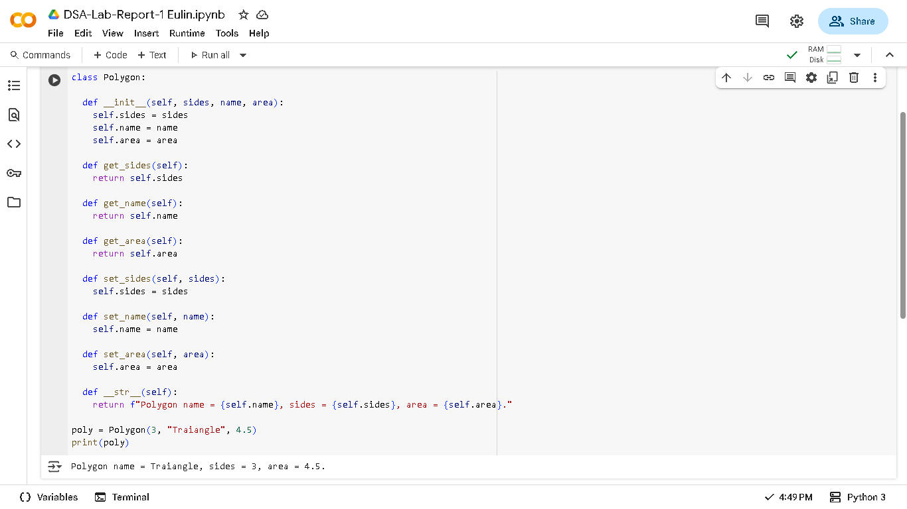

Here is my answer in Part B where we’re task to make a class (Polygon) where it have 3 instance but, I make 6, 3 to get the name, sides, and return it, and another 3 for setting it, since I can also use the def __init__(self) alone as it’s method I made it like this so I can have a better control and practice more OOP like Encapsulation since, I let the class(Polygon) manage it’s own data (get_ and set_ functions).

# Conclusion

In my conclusion, this laboratory helps me to learn more about __init__ and also explore what __str__ do in python. Also, creating a diagram from scratch and visualize how do we want to create a working system, not just we’re building project but solving a problem by automating.

**References**

[1] Co Arthur O.. “University of Caloocan City Computer Engineering Department Honor Code,” UCC-CpE Departmental Policies, 2020.